Emma Leach
T00683129

Itinerary

MY SECRET SANTA (ITINERARY #1)
8-10 hours experience
Location | Experience/Activities
Sun Peaks Grand Hotel Lobby  9:00am  30mins – 1 hour recommendation | Coffee/breakfast  Photos by the fireplace
Village Square + Mantles  9:30-10:00am  30 mins – 1 hour recommendation | Walk the village  Browse shops  Brunch/light snack
Learning Zone  11:30am  2.5-hour recommendation  (if not into winter sports, spend more time exploring the village/shops) | Ski Lesson (2 hour options, https://www.sunpeaksresort.com/ski-ride/sports-school-rentals/lessons-camps-programs/learn-to-ski-and-snowboard-lessons)  Watching activity  Photos  Seasonal Swaps:  Summer: Hiking/biking trails  Fall: walks/viewpoints  Spring: walks/photography
Morrisey’s Public House  2:00pm  1 - 2-hour recommendation | Drinks/snacks  Warm up by fire tables or patio
Village + Free Time  4:00pm  1 hour recommendation | Explore shops  Visit Sun Peaks Centre  Rest before evening
Oya Japanese Restaurant  5:30pm | Dinner
Village Stroll (Night)  After dinner | Photos with lights  Holiday atmosphere

2-DAY “CITY TO SUMMIT” ITINERARY
KAMLOOPS + SUN PEAKS EXPERIENCE
Location | Experience/Activities
DAY 1  Barnacle Records  10am  30mins-1 hour recommendation | Browse records  Connect to the film
Brunch  11:00am  1 -2h recommendation | Hello Toast  The Chook Eatery  Kirsten’s Hideout Café  The Columbia Diner  The Art We Are  Red Beard Café  Bright Eye Brewing
Rivers Trail  12:30pm  1-1.5h recommendation | Riverside Walk  Scenic, relaxed  Skating Rink
Culture Stop  2:00pm  1-1.5h recommendation | Kamloops Art Gallery  Kamloops Museum
Free time  1-2h recommendation | Downtown shopping  Coffee stop  Rest before dinner
Dinner  5:30pm | The Noble Pig  Brownstone Restaurant  Peters Pasta  Bright Eye Brewing  Casa Azul Mexican  Embers Brewhouse
OVERNIGHT STAY
DAY 2  Drive to Sun Peaks  9:00am (45-1h) | Scenic drive
Follow Sun Peaks Itinerary  10:00am-7:30pm | Hotel  Village  Ski  Après  Dinner  Evening Stroll
Stay overnight in Sun Peaks OR return to Kamloops
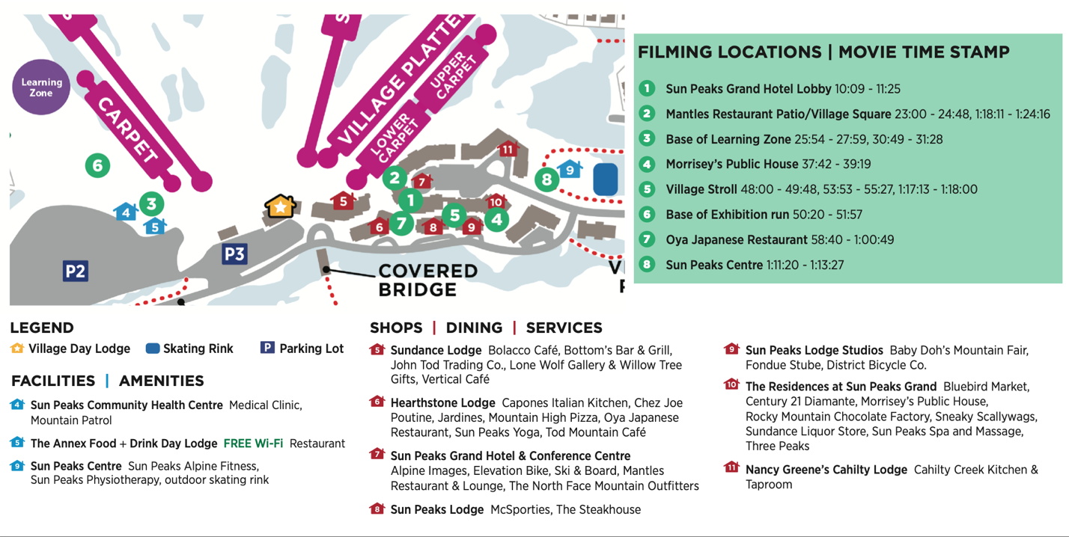

City to Summit – Kamloops + Sun Peaks (2-day Experience)
From downtown culture to mountain adventure

Kamloops offers a unique blend of city life and stunning landscapes. This two-day itinerary invites visitors to experience both sides of the region, beginning in downtown Kamloops before heading to the slops of Sun Peaks.

Day 1 – Discover Kamloops

This iconic downtown shop featured in the film My Secret Santa is the perfect way to start of your 2-day adventure. Visit Barnacle Records and browse through their collections of vintage vinyl before heading out for brunch.

Kamloops’ downtown food scene offers a wide variety of local favourites. Restaurants such as Hello Toast, The Chook Eatery, or Red Beard Café are the perfect places to fuel up for the day ahead.

After brunch, take a scenic walk along the River Trail, where the North and South Thompson Rivers meet. The riverside path is one of the city’s most peaceful routes and plenty of spots to pause and relax. During the winter season, the park becomes even more magical with the Riverside Park skating loop. Rent a pair of skates, lace up, and glide along the outdoor rink. It’s the perfect place to create your own “meet-cute” moment, just like Taylor and Matthew in My Secret Santa.

Continue your afternoon to take in the culture at the Kamloops Art Gallery or Kamloops Museum. Learn more about the region’s history and artistic community.

For the evening, enjoy dinner at one of Kamloops popular restaurants such as The Noble Pig, Brownstone Restaurant, or Peters Pasta. Each place offers a unique taste of the city’s dining scene.

Rest up at your hotel before the next day’s mountain adventure!

Day 2 – Sun Peaks Adventure

This morning starts off with a scenic 45-minute drive from Kamloops to Sun Peaks Resort. Pass through the rolling hills and mountain landscape as you head into the village.

Once you arrive, spend the day exploring the village featured in My Secret Santa. Start at the Sun Peaks Grand Hotel, stroll through the charming village square, browse boutique shops, and take in those views!

Feeling adventurous? Try a ski or snowboard lesson in the Learning Zone. There’s no better way to experience Sun Peaks than on the mountain! Enjoy apres-ski at Morrisey’s Public house and finish the evening with dinner at Oya Japanese Restaurant.

The best way to end the night is an evening stroll. While you head back to your car to return to Kamloops, take a walk through the village to see all the twinkling lights.

MY SECRET SANTA KAMLOOPS PRIORITY
Location | Experience/Activities
Sun Peaks Grand Hotel Lobby  9:00am  30mins – 1 hour recommendation | Coffee/breakfast  Photos by the fireplace
Village Square + Mantles  9:30-10:00am  30 mins – 1 hour recommendation | Walk the village  Browse shops  Brunch/light snack
Learning Zone  11:30am  2.5-hour recommendation  (if not into winter sports, spend more time exploring the village/shops) | Ski Lesson (2 hour options, https://www.sunpeaksresort.com/ski-ride/sports-school-rentals/lessons-camps-programs/learn-to-ski-and-snowboard-lessons)  Watching activity  Photos  Seasonal Swaps:  Summer: Hiking/biking trails  Fall: walks/viewpoints  Spring: walks/photography
Morrisey’s  2:00pm  30min-1hr recommendation | Quick snack/fuel up
Drive to Kamloops
45 minutes
Riverside Park  1hr-1.5hr recommendation  4:00pm | Skating rink  Lights  Romantic atmosphere
Eden Bento Café  5:30pm  1hr-1.5hr | Dinner
Downtown Stroll | Photos with lights

Map of Itinerary
https://www.google.com/maps/d/u/0/edit?mid=1iYWCuEdgsnlSNBbJEDAm6fFtW2puhpY&usp=sharing

My Secret Santa – Kamloops Priority Route
A romantic winter journey

Step into the festive world of My Secret Santa! This itinerary gives the best of winter, the alpine charm of Sun Peaks, with the cozy winter atmosphere of Kamloops.

Start your morning in the Sun Peaks Grand Hotel lobby, a warm and welcoming starting point for the day, just like in My Secret Santa. Grab a coffee or light breakfast and relax by the fireplace before heading outside into the crisp mountain air.

From there, stroll into the centre of Sun Peaks, Village Square. Browse boutique shops, take photos with the best backdrops, or enjoy a light brunch at Mantles Restaurant while watching skiers glide down the slopes.

Remember watching those skiers, now it’s your turn! Make your way to the Learning Zone where you can take part in a ski or snowboard lesson. Not up to hitting the slopes this time? No worries! This is a great place to watch the action, take photos, and soak up the views up close.

Get ready for a change of scenery! After a quick stop at Morrisey’s Public House for a warm drink or snack, begin the scenic 45-minute drive back to Kamloops.

Once in the city, head to Riverside Park, one of Kamloops’ most beloved gathering spots. In winter, the park’s skating loop and festive lights create a romantic atmosphere perfect for an evening stroll or skate!

Finish the evening with dinner at Eden Bento Café, a cozy downtown restaurant. After, take a relaxing walk through downtown Kamloops to enjoy the nighttime city views.

LISTEN OUT OF LOVE ITINERARY
6-8 hours
Location | Experience/Activity | Movie Time Stamp
Thompson Rivers University  House of Learning  10:00am  30 mins – 1hr recommendation | Walk through campus  Visit House of Learning exterior  Views of Kamloops | 1:28-3:40, 6:04 – 6:53, 13:34 – 15:48, 18:31 – 21:44, 24:24 – 27:25, 34:52 – 36:24, 47:11 – 49:11, 51:46 – 52:45, 58:43 – 1:03:14, 1:04:33 – 1:05:31, 1:09:18 – 1:11:17, 1:14:05 – 1:15:16, 1:19:37 – 1:20:57
Amplified Café  11:00am  1hr-1.5hr recommendation | Coffee/lunch  Relax  Observe city life | 3:40 – 6:00, 40:55 – 45:19, 1:15:17 – 1:15:51
Riverside Park and Rivers Trail  12:30pm  1.5 – 2hr recommendation | Walk or bike the river trail  Visit the Japanese Garden  Picnic | 6:54- 8:04, 15:49 – 18:28, 27:26 - 30:05, 45:39 – 47:10, 49:12 – 51:45, 52:46 – 58:41, 1:11:19 – 1:13:37, 1:18:09 – 1:19:36
Cliffside Climbing Gym  2:30pm  1-1.5hr recommendation | Try indoor climbing | 8:34 – 12:35
Cordo Resto + Bar  5:30pm  1.5 – 2hr recommendation | Dinner and drinks | 12:45 – 13:32, 34:25 – 37:17, 1:05:34 – 1:09:12
Downtown Kamloops and Pedestrian Bridge | Walk downtown  Cross the pedestrian bridge  Watch sunset over the river | 1:03:15 – 1:04:32, 1:13:41 – 1:14:03

Map of Itinerary
https://www.google.com/maps/d/u/0/edit?mid=1xN8UB6NiyqRrWlOgADrb0GLon5nAk_s&usp=sharing

Listen Out of Love – Kamloops Film Experience
Step into the scenes of this romantic film

Listen Out of Love was filmed in several locations across Kamloops, highlighting the city’s scenic riverfront, vibrant downtown, and welcoming campus environment. This itinerary allows you to follow the path of the film while exploring some of Kamloops’ most recognizable places.

Start your day at Thompson Rivers University, where many scenes were filmed around the House of Learning. Walk through the campus pathways and take in views overlooking the city.

Next, head downtown to Amplified Café, a cozy spot featured in the film. This is where the film slows down – where conversations start to get deeper and feelings begin to develop. Enjoy coffee or lunch while watching the city unfold outside the windows.

From there, explore Riverside Park and the River Trail, where several memorable scenes take place. Walk or cycle along the riverfront, visit the peaceful Japanese Garden, or relax by the water. In the winter, the Riverside Park skating loop adds a charming seasonal experience. Surrounded by lights and snowy scenery, the outdoor rink creates a magical setting where you can create your own “meet-cute” moment!

For a bit of adventure, visit Cliffside Climbing Gym. Try indoor climbing just like Peyton and
Alex.

End the day with dinner at Cordo Resto + Bar, before taking an evening walk through downtown Kamloops and across the pedestrian bridge. The perfect way to end your romantic evening.

Mock Up

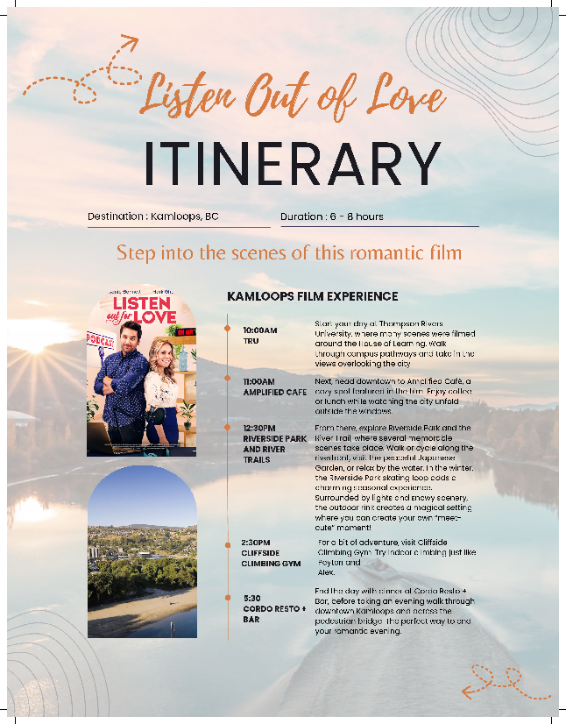

Choose your Scene:

The Explorer: Move through landscapes that have stood in for collapsing cities, distant planets, and survival worlds.

Location | Experience/Activity | Film Connection
Kenna Cartwright Nature Park  9:00am  1-1.5hr recommendation | Hike to viewpoint  Capture wide landscape photos  See the valley | 2012/The A-Team rely on landscapes like this
Lac du Bois Grasslands Protected Area  11:00am  2.5-3hrs | Walk through grassland trails (Mara Trail 3.5km, Cinnamon Ridge Trail 4. 25km, Dewdrop Trail 5.7km)  Experience open, quiet terrain  Wildlife | Post-apocalyptic terrain (Maze Runner)  Uninhabited environment (Battlestar Galactica)  Survival settings (The Last of Us)  X-Files
Rest/Lunch  1:00pm | Pack a lunch and take a break in the landscape
Battle Bluffs Trail  2:30pm  1.5-2hrs recommendation | Moderate hike to the bluff  Overlook the Thompson River Valley | The A-Team/2012 for movement scenes
Post-Hike Reward  5:00pm | Bright Eye Brewing  Red Collar Brewing & Distilling
Optional:  Greenstone Mountain | Stargazing  Night photography | Sci-fi atmospheres  Remote-world settings  Lost in Space

Map of Itinerary:
https://www.google.com/maps/d/u/0/edit?mid=13G8GGkdtD1M9314g6rugEJklKvaQcBc&usp=sharing

Choose Your Scene – The Explorer
Experience landscapes that have appeared on your screen

Kamloops’ terrain has appeared in films and television shows ranging from apocalyptic thrillers to sci-fi adventures. This experience invites visitors to explore the landscapes that helped create these cinematic worlds.

Begin the day at Kenna Cartwright Nature Park, one of the largest municipal parks in British Columbia. A short hike leads to breathtaking viewpoints overlooking the Thompson Valley – just like in 2012 and The A-Team. Standing at the top, imagine the kind of urgency seen in 2012, where characters race across the collapsing terrain, scanning the horizon for a way out. The scale of the valley creates the same tension that is vast, exposed, and unpredictable. It’s also reminiscent of scenes from The A-Team, where Hannibal’s team moves strategically through open landscapes, always aware that the environment is part of the challenge.

The experience deepens at Lac du Bois Grasslands Protected Area. Here, the terrain becomes quieter and more immersive. The rolling hills and open sky reflect the isolated environments seen in Maze Runner: The Death Cure, where Thomas first begins to understand the world beyond the maze. The grasslands create the same sense of isolation and uncertainty, where every direction feels possible, but nothing is fully known.
The same environment echoes in Battlestar Galactica, where Kara “Starbuck” Thrace navigates unfamiliar planets, relying on instinct as much as direction. The openness here creates the same feeling, as if you’ve stepped into a place where survival and discovery are closely linked.
Even The X-Files comes to mind, where Mulder and Scully investigate remote, unexplainable phenomena in landscapes just like this. Places where the silence feels intentional, and every detail matters.

Pause here for lunch, while surrounded by the grasslands, before continuing to Battle Bluffs Trail. This rewarding hike offers panoramic views over the Thompson River valley. Reaching the top feels like stepping into a turning point. The kind of moment where a character looks out over the terrain and finally understands the scale of what they’re up against.

After a full day outdoors, return to the city for a well-earned reward at Bright Eye Brewing or Red Collar Brewing & Distilling, both popular Kamloops spots.

For those seeking a true cinematic ending, head to Greenstone Mountain for an evening of stargazing and night photography. With little light pollution, the sky creates the perfect setting for imaging distant worlds, as seen in Lost in Space.

Choose Your Scene – The Investigator
6–8-hour experience
Solve the mystery hidden in Kamloops
Location | Time | Experience/Activity
Bill Miner Mural  120 5th Ave | 9:30am | Begin the investigation with the story of Bill Miner, the legendary “Gentleman Bandit” know for Canada’s early train robberies. View the mural and imagine the outlaw history tied to the region’s railways.
Railway Corridor/Riverside Area | 10:00am  30-1hr recommendation | The investigation continues along Kamloops’ railway corridor and riverfront, where trains still pass through the valley.
Downtown Kamloops Walk | 11:00am  30-1hr recommendation | During your downtown walk, you become the investigator. Using this still image from Power Rangers, try to locate the exact cross street where the scene was filmed. Look for building details, signage, and street layout to solve the clue.
Lunch Downtown | 12:00pm  1hr-1.5hr recommendation | Fuel up at The Chook Eatery or Stone & Wood Public House before continuing the investigation.
Exit Room | 1:30pm  1hr | Next, put your detective skills to the test at a local escape room, where you must decode clues, uncover hidden messages, and solve puzzles before the time runs out. This interactive experience brings the investigator theme to life and challenges you to think like a real detective.
Kenna Cartwright Nature Park or Peterson Creek | 2:30pm  1.5-2hr recommendation | Continue the investigation with a short hike to a scenic view of the Thompson Valley. These dramatic landscapes have appeared in productions like The X-Files, Battlestar Galactica, and The Maze Runner, where Kamloops stood in for mysterious and remote worlds. Standing above the valley, you can imagine you’re at the final moment of a mystery story – where the last clues fall into place.
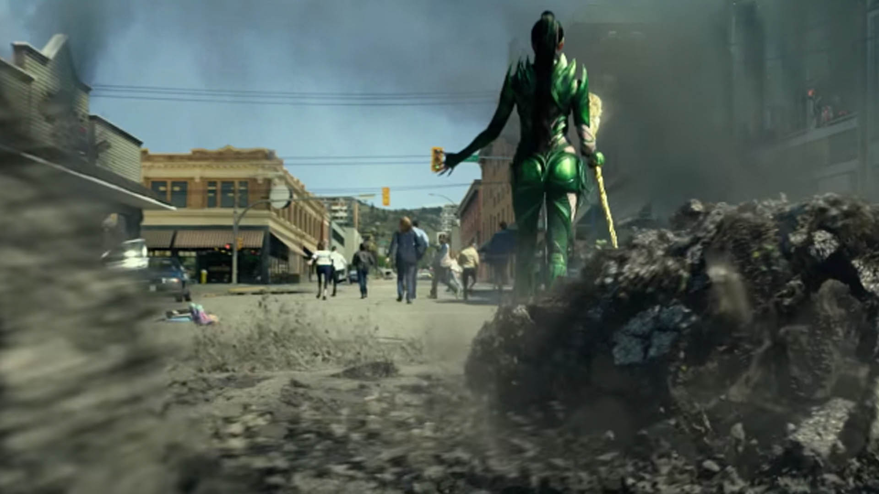
Power Rangers Downtown Kamloops (https://cfjctoday.com/2017/01/19/new-power-rangers-trailer-showcases-kamloops-2/)

Map of Itinerary
https://www.google.com/maps/d/u/0/edit?mid=1Cin_1qQyrjxCxepAj_NXViOHXvFD81o&usp=sharing

Every investigation starts with a story, and in Kamloops, that story begins with a legend.

At the Bill Miner Mural, you’re introduced to the “Gentleman Bandit,” whose train robberies feel like something straight out of a classic crime film. Like many cinematic outlaws, Miner’s story is calculated and elusive.

From there, the investigation moves into the railway corridor, where the sound of passing trains adds a sense of tension. It’s easy to imagine scenes like those in The X-Files, where Mulder and Scully follow leads into remote locations, never quite sure what they’ll find. The environment feels active, like something has happened here, and you’re just beginning to piece it together.

Downtown, the role becomes yours. Inspired by filming locations from Power Rangers, Kamloops transforms into a place of hidden details. Just as Jason and his team begin to uncover their roles and piece together what’s happening around them, you’ll begin to do the same. Using this still image from Power Rangers, try to locate the exact cross street where the scene was filmed. Look for building details, signage, and street layout to solve the clue.

Fuel up at The Chook Eatery or Stone & Wood Public House before continuing the investigation.

Inside an escape room, the pressure builds. Like any good mystery, each clue leads to another, and every solved piece reveals something new. The pacing mirrors the structure of a thriller, where time is crucial, and understanding unfolds one step at a time.

The final chapter unfolds in the landscape. At Kenna Cartwright Nature Park or Peterson Creek, the elevation brings perspective. These are the kinds of settings seen in Maze Runner: The Death Cure or The X-Files, where characters step back, look at everything they’ve uncovered, and finally begin to understand the bigger picture. Standing above the valley, everything feels connected. The clues make sense, the story comes together, and the investigation is complete.

Choose Your Scene – The Romantic
Step into your own love story in Kamloops

Location | Time | Experience/Activity
Morning Coffee Date | 10:00am  1-1.5hr recommendation | Start the day at a cozy Kamloops café such as Red Beard Café. Relax over coffee and imagine the opening scene of a romantic film. Down the street you can spot a movie set sign from An Unfinished Life at the local Prop & Track Recreation store.
Horseback Riding Adventure | 11:30am  1.5-2hr recommendation | Take a guided horseback ride through the grasslands or countryside near Kamloops, enjoying the sweeping valley views. This activity reflects the landscapes seen in films such as Flicka 2 and The Movie Star and the Cowboy, where the wide-open countryside creates meaningful connections.  https://www.erinvalleyridingstables.com/trail-rides.html
Riverside Picnic | 1:30pm  1-1.5hr recommendation | Pick up lunch from a local café or bakery and enjoy a picnic beside the Thompson River in Riverside Park. Scenic romance moments like this are seen in Listen Out of Love
Kenna Cartwright Nature Park | 3:00pm  1.5-2hr recommendation | Head to Kenna Cartwright Nature Park for a short walk and panoramic views of the Thompson Valley.
Dinner Date | 5:30pm | Enjoy dinner at one of Kamloops’ cozy restaurants like Cordo or Brownstone
Downtown Stroll | After dinner | End the evening with a romantic stroll through the city.

Map of Itinerary
https://www.google.com/maps/d/u/0/edit?mid=1-79caD7ek1PEF52VAjcxiN5EMoV_3V0&usp=sharing

Let your story unfold, one moment at a time.

Every romantic story begins quietly. At a café like Red Beard Café, the morning feels simple, familiar, and full of possibility. Similar to the tone of An Unfinished Life, where characters like Einar and Jean reconnect through small, meaningful moments. Sitting across from someone here, with coffee in hand, it’s easy to feel that same sense of something slowly beginning.

From there, the story opens into the landscape. A horseback ride through the countryside brings you into the same wide-open settings seen in Flicka 2, where Katy finds a connection with the land around her. The steady rhythm of the ride and the quiet of the surroundings create space for reflection. This feeling continues in the spirit of The Movie Star and the Cowboy, where characters step away from the spotlight and into something more real. Out here, the pace slows, and the focus shifts to the experience itself.

Continue your romantic journey to Riverside Park. Walking along the water or sitting down for a picnic, it’s easy to picture moments from Listen Out of Love, where Peyton and Alex share quiet conversations that gradually deepen their connection. The river moves steadily beside you, and everything feels unhurried.

As the afternoon continues at Kenna Cartwright Nature Park, the elevated view creates a moment of clarity. It’s the kind of scene where a character pauses, looks out, and realizes something has changed for the better.

The evening brings everything together. Dinner at Cordo or Brownstone feels like the movie is coming to an end. And as you step out into the evening for a quiet downtown stroll, the story settles into its final moment.

Like the best romantic films, nothing needs to be said. The setting does the work for you.

